#1 – Page 8. Change to Publication in order to set consistent timeframes to publish Kingdom Law changes.
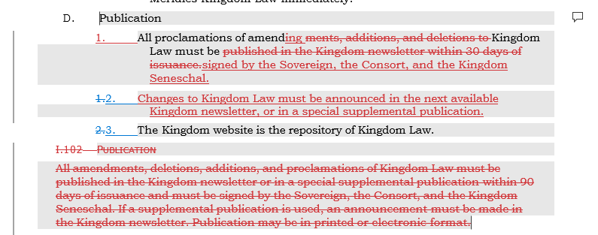

#2 - Page 16 - 17. Changes to Succession, Per Society Seneschal Guidance. (Published in Pop Chiv and Kingdom Webpage).

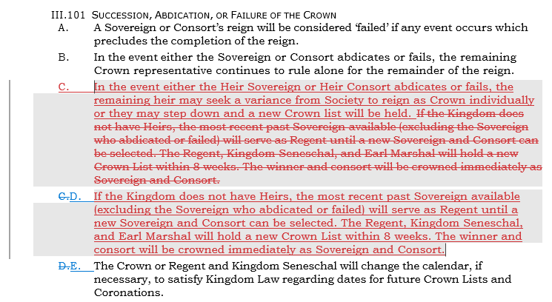

#3 – Page 27. Clarification to KLEs, bid may be day event if appropriate.

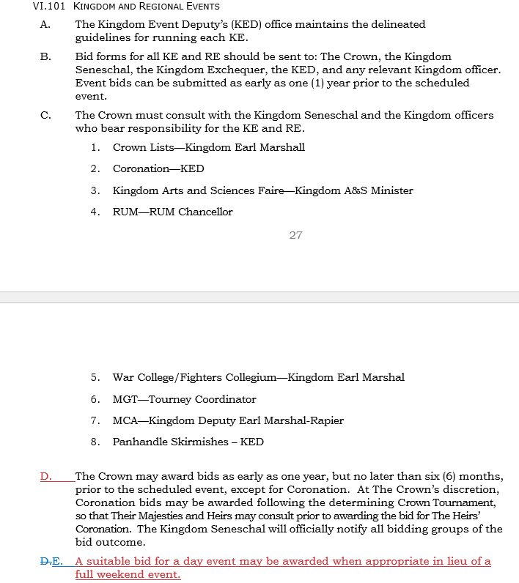

#4 – page 28. Remove reduced fee for Herald’s submission, no longer done.

